PMMA Resin

ACRYREX is a plastic material successfully manufactured by the Chi Mei Corporation using methyl methacrylate (MMA) as the main raw material after three decades of acrylic sheet manufacturing experiences and the introduction of continuous process technology from the United States. It has good cleanliness, high transparency and gloss, as well as stable physical, chemical, optical, and electrical properties. Can be widely used in the application of electronic panels, mechanical parts, surfaces of watches and clocks, vehicle lights, telecommunication equipment, insulation parts, and sunglasses.

[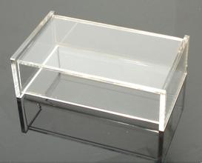](http://image.baidu.com/i?ct=503316480&z=&tn=baiduimagedetail&ipn=d&word=PMMA%E7%9B%92%E5%AD%90&step_word=&ie=utf-8&in=10224&cl=2&lm=-1&st=-1&pn=144&rn=1&di=107834293710&ln=1993&fr=map0000&&fmq=1392359371330_R&ic=0&s=&se=1&sme=0&tab=&width=&height=&face=0&is=&istype=2&ist=&jit=&objurl=http%3A%2F%2Ffreeimg.soso2.com%2F79%2Ff4%2F02%2F971568951%2Fb8%2F9f%2F6f%2F1264070723812.jpg)[](http://image.baidu.com/i?ct=503316480&z=&tn=baiduimagedetail&ipn=d&word=PMMA%E7%9B%92%E5%AD%90&step_word=&ie=utf-8&in=23819&cl=2&lm=-1&st=-1&pn=179&rn=1&di=161138081940&ln=1993&fr=map0000&&fmq=1392359371330_R&ic=0&s=&se=1&sme=0&tab=&width=&height=&face=0&is=&istype=2&ist=&jit=&objurl=http%3A%2F%2Fimglogo.wjw.cn%2Fmbr1005%2Fmbr100508124834434821%2FPicImgLogo%2FIMG111027153829109907.jpg)

[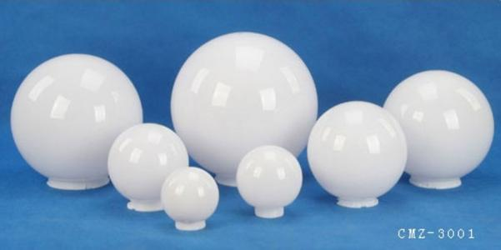](http://image.baidu.com/i?ct=503316480&z=&tn=baiduimagedetail&ipn=d&word=PMMA%E7%81%AF%E7%BD%A9&step_word=&ie=utf-8&in=6877&cl=2&lm=-1&st=-1&pn=2&rn=1&di=23400496900&ln=1995&fr=map0000&&fmq=1392359463402_R&ic=0&s=&se=1&sme=0&tab=&width=&height=&face=0&is=&istype=2&ist=&jit=&objurl=http%3A%2F%2Fimage.cn.made-in-china.com%2F2f0j01ZvcaYmQhZiud%2F%25E5%259C%2586%25E7%2590%2583%25E7%2581%25AF%25E7%25BD%25A9.jpg)

[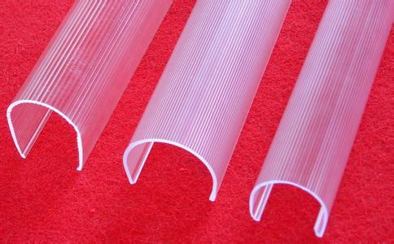](http://image.baidu.com/i?ct=503316480&z=&tn=baiduimagedetail&ipn=d&word=PMMA%E7%81%AF%E7%BD%A9&step_word=&ie=utf-8&in=21337&cl=2&lm=-1&st=-1&pn=40&rn=1&di=191848273210&ln=1995&fr=map0000&&fmq=1392359463402_R&ic=0&s=&se=1&sme=0&tab=&width=&height=&face=0&is=&istype=2&ist=&jit=&objurl=http%3A%2F%2Fwww.sh.jzqyw.com%2Fdata%2Fupfile%2F20090519135811919173.jpg)